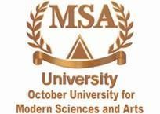
MSA university, Faculty of pharmacy,
Pharmacognosy Department, Pharmacognosy (PHG 112)
Fall (2025))
Students are asked to submit a poster with the topic given in
the lab.
Perform it according to the following criteria:
- The Poster should start with a collective summarized introduction about the Disease, then each student will put the following information about his/her plant:
  - Origin of the chosen plant (including part used, genus, species, family, English and Arabic name).
  - Picture of the organ used from the plant (with the highest content of the main active constituent).
  - Active constituents (provide the structure of the main active constituents).
  - Uses of the plant (with pictures as possible).
  - The mechanism of action of the main active constituent (summarized).
  - Picture of the pharmaceutical preparation from the Egyptian or the international market that include the whole plant, an extract, or a compound from this plant.



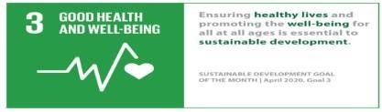
******Make sure that the fonts are clear, student names, ID, Course name, Code, and Course Coordinator are written under the title,- MSA and Greenwich logo is included- and all the used references are included. In addition to the SDG logo:
- References are written in numerical style.
- The poster dimensions is A3 with white background.
- The font is Times New Roman.
- It should be submitted as Pdf file.
- Font Size (Title 60, Heading 24 and Text 20)
- All the information should be clear, summarized and to the point with the addition of illustration as much as possible.

- Discussion will be on Saturday 20/12/2025 H207/H307

