Bus 304 Business Plan First Phase Fall 2023

Executive Summary

What is included? An executive summary should summarize the key points of the report. It should restate the purpose of the report, highlight the major points of the report, and describe any results, conclusions, or recommendations from the report.

Your executive summary should include:
- The name, location, and mission of your company.
- A description of your company, including management, advisors, and brief history.
- Your product or service, where your product fits in the market, and how your product differs from competitors in the industry.

Company Overview

The Company Overview is a one page description of the company you have
founded or want to found. Upon reading this section, the reader should have a
good idea of where you are now and where you are going with your company.
It typically summarizes details like the company's history, management structure, mission statement, location and legal organization. Business professionals can use this document to introduce potential investors or other key stakeholders to a company by outlining its core values and goals.

Introduction

Write a paragraph that briefly outlines the history and current status of your
company. What is the legal entity? Who owns the company now?

A mission statement defines the organization's business, its objectives, and how it will reach these objectives.

A vision statement details where the organization aspires to go. Why does your company exist? What do you hope to accomplish in the next several years?

The Business Model
The business model canvas is a tool designers use to map out a business or product’s key actors, activities and resources, the value proposition for target customers, customer relati onships, channels involved and financial matters. It gives an overview to help identify requirements to deliver the service and more.
“A business model describes the rationale of how an organization creates, delivers, and captures value.”

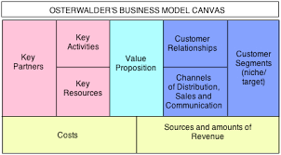

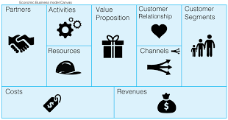

Competitive Advantage
Write a brief description of your sustainable competitive advantage. Consider the
following:

• Internal capabilities – What are your skills, experience, resources, and
tangible and intangible assets?

• Differentiation – How are you unique in the marketplace?

