The Faculty of Management Sciences
Entrepreneurship & Small Business Management (BUS412N)
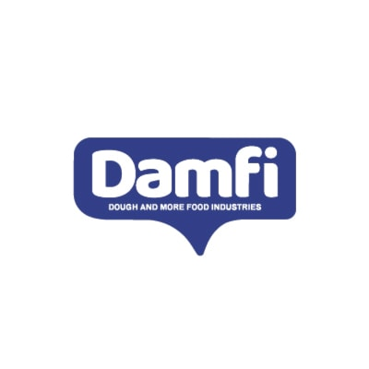
Submitted to: Dr. Zeinab Zaazou
T.A Rawan Sameh

Group members:
Ahmed waleed 201997
Farida Ehab 202171
Feryal Hesham 202257
Azza Ahmed 201839

FALL 2022

Table of contents:

1.Executive summary: 3
1.1key people: 3
1.2 About the company: 3
1.3 About the market: 4
1.4 Strategies that will make the firm a success: 5
1.5 Brief Description Brief description of the managerial and technical experience of key people: 6
2. Vision and mission statement 7
2.3 What Business are we in? 7
2.4 Values and Principles in which the business stands 7
3.Company History 9
3.1 Company foundings: 9
3.2. Financial and operational highlights 9
3.3. Significant Achievements. 9
4. Business and Industry Profile 10
4.1 Industry analysis: 10
4.1.1 significant trends: 10
4.1.2 Growth Rate : 11
4.1.3 Key success factor: 12
4.2 Outlook for the future: 13
4.3 stage of growth: 13
4.4 Goals and Objectives: 13
5. Business strategy: 14
5.1 desired image and position: 14
5.2 SWOT Analysis: 14
6. Company product and services: 15
6.1 Description: 15
6.1.1 Product or service features: 15
6.1.2 Customer Benefits: 16
6.1.3 Warranties and Guarantees: 16
6.1.4 Unique Selling Proposition: 16
6.2 future product or service offerings: 17
7.Marketing strategy: 17
7.1 Target market: 17
7.1.1 Demographic profile: 17
7.2 other significant customer characteristics: 17
7.3 Market size and trends: 18
7.4 Generic Strategy: 18
7.4.1 How large is the market? 19
7.4.2 Is it growing or shrinking? 19
7.5 Advertising and promotion: 20
7.6 Pricing: 20
7.7 Distribution strategy 21
8. Pest analysis 21
9. Competitor analysis : 22
9.1 Existing competitors: 22
9.2 potential Competitors: 23
9.3 CPM : 23
10 .Guerrilla marketing: 24
11. Financial Forecasts: 24
References: 28

Company Name: Dough & More Food Industries (DAMFI)

Website: www.damfi.com

Address: 6TH of October, GIZA

1.Executive summary:

1.1key people:
1- Tarek El Nazer (chairman)
Email: info@damfi-eg.com

2-Osama Aladl_ (Executive chairman of the BOD & CEO)
Email: info@damfi-eg.com

3- Mohamed Mansour (Board member)
Email: info@damfi-eg.com

1.2 About the company:
Early in 2019, an Egyptian joint stock company called Dough & More Food Industries (DAMFI) was founded with the goal of setting a new benchmark for food production in Egypt that would be unrivalled in terms of quality. DAMFI now runs a 15,000 sq m state-of-the-art manufacturing facility in 6th October City, fully equipped to produce premium quality baked goods to delight Egyptian consumers, after devoting significant effort and investment and assembling a team of the most skilled and competent professionals across Egypt and the Middle East (Damfi , 2021).

Products made by DAMFI include 1-Bread way ®, a premium-quality loaf of bread made utilising a special sourdough fermentation technique that gives it a richer flavour and softer texture. Bread way® is lighter on the stomach and simpler to digest than most commercial bread because of the wild yeast in our dough. We provide you with a wide selection of breads, including Arabic bread, brioche, tortilla, and buns & rolls. This ensures that you are the first person to touch the bread because it is delivered to you in a carefully sealed package, giving you peace of mind about the health and safety of your family. At Bread Way®, we provide you with a broad and varied selection of breads, including Lebanese Bread, Burger Buns, Petit Pain, Soft Rolls, and Whole-wheat with 7 Seeds Toast (Plain & Bran). With Brioche Bread (Brioche Toast, Brioche Rolls, and Brioche Rolls with Chocolate Chips) prepared with a rich and delicate balance of milk and butter, Tortilla bread (Plain & Bran) to help you prepare delicious wraps, and finally crust less Toast for all club-sandwich lovers, our recently introduced Bread way ® Selections® range elevates commercial bread to new heights. With bread way ®, enjoy your sandwiches.
Special orders: Various round bun varieties (3.5 "Sesame, corn, sunflower, linseeds, and semolina are some of the different types of seeds and grains that can be used as toppings. Other surface decorations include splitting, double splitting, and braiding. Various elongated roll types (4.75", 5", 7 "(McDonald's, Hardee's, Americana, Buffalo, Heart Attack, and Bazooka) use various surface decorations, such as single splitting, with various types of seeds and grains for topping, such as sesame, corn, sunflower, linseeds, and semolina.

DAMFI takes every effort to assist customers and find solutions to their difficulties. If a customer has a problem, they can get in touch with them or send them a message. DAMFI strives to provide high-quality, fresh products. If a consumer purchases a product from DAMFI and discovers a problem with it, there is a return policy that allows for a product exchange. We must constantly adapt due to the quick changes in consumer needs, rising technology, and the ongoing desire to reduce product costs.

1.3 About the market:
The industry that has been expanding quickly lately is the food industry. Our continual goal at DAMFI is to improve our brand experience and develop our position in the Egyptian food sector so that we can consistently surpass our customers' expectations by providing them with high-quality, secure, and healthy goods and services.
Naturally, none of this would be possible without a cutting-edge manufacturing facility that produces goods in accordance with national and international regulations, allowing us to compete and succeed in the sector thanks to best manufacturing practises, quality optimization, and manufacturing scale.
Highly skilled and trained manufacturing staff in production, quality assurance, compliance, and engineering. Top-notch European manufacturing lines from renowned suppliers. Selected and sourced the highest quality ingredients and raw materials.
By introducing sourdough technology for the first time in Egypt and using cutting-edge packaging that ensures the consumer the highest levels of safety, hygiene, and product freshness, we believe that DAMFI is currently the smartest and most technologically advanced company in the Egyptian packaged bakery industry. DAMFI has the potential to become a significant regional player. DAMFI continues to expand the distribution of its products both at the retail and foodservice levels, expanding its coverage to reach almost 10,000 retail outlets nationwide and making DAMFI products accessible to a significant portion of Egyptian households. This is done with the help of a growing fleet of sales trucks and a network of regional distributors. By working together with all modern trade customers in Egypt, we are able to achieve best-in-class product visibility with the help of a committed merchandising team.
However, they catered to middle-class and affluent clients who wanted to develop their products; we were ready to assist. Our research and development is accessible to satisfy the demands of our consumers and customers, whether that means creating new products to meet those needs or updating and developing existing products to meet those needs.

1.4 Strategies that will make the firm a success:
DAMFI use sourdough technology for the first time in Egypt, in addition to state-of-the art packaging that guarantees the consumer the highest levels of safety, hygiene and product freshness.

Food Safety:
At DAMFI, we recognize that a successful culture of food safety and quality can only be achieved by following safe work practices and procedures to produce a product that is healthy and safe for consumers and meets their needs and expectations by complying to all relevant laws and regulations in food safety and systematically training our employees in that field.

Environmental Safety:
DAMFI is committed to comply with all relevant laws and regulations in the environmental field related to the company, to operate our facilities and technologies in accordance with the protection of the environment and preserve natural resources, as well as ensure that the various activities and their outputs comply with the regulating laws and specifications.

Occupational Health:
We believe in a "Safety First" policy towards any HSE noncompliance through continuous research and risk management to create a safe, healthy and non-threatening work environment for all employees and other persons in our workplaces, fulfilling legal and other requirements.

1.5 Brief Description Brief description of the managerial and technical experience of key people:

Tarek El Nazer (Chairman)
Tarek is an Accounting and Finance graduate with a passion for starting up and leading pioneer bakery brands in the Egyptian market. He is a member of TBS Holding, the highest shareholder in DAMFI. Together with Sameh El Sadat, Bassel Mashour and Yasser Abdelsalam, Tarek founded TBS, a leading group of food services companies, established in 2008, owned by Native Markets Ltd. which was established in 2014 to act as the holding company for TBS and the rest of its subsidiaries; Delicious Bakery, Rihana for advanced food S.A.E, and the Four Fat Ladies LLC.

Dr.Osama Al Adl (Executive Chairman Of The BOD And CEO)
A seasoned strategic management executive, with 25+ years of experience in driving the culture of innovation, initiative and exceeding productivity by optimising manufacturing operations, mitigating costs and subsequently improving profitability.
Championed a sustainable LEAN organization and continuous improvement culture, led company-wide transformation that enabled delivery of breakthrough levels of performance.
Characterized as a growth catalyst, provided visionary sales leadership to exceed P&L goals and targets. He is recognized for exceeding productivity, igniting performance and boosting bottom-line growth to unparalleled achievements.

Mohamed Mansour (Board Member)
Mohamed is Chairman and Managing Director at Manfoods (McDonalds Egypt)/Infinity Group

2. Vision and mission statement
2.1 Vision
With a passion for excellence and innovation, the vision at DAMFI is to become the leading company in the field of baked goods production in Egypt by creating a new standard and concept of bakery, designed and crafted to delight consumers with tastier & healthier baking innovations using the latest technology & finest ingredients.
2.2 Mission
The company mission of each member of the DAMFI team is to provide great tasting healthy food products using world-class manufacturing technologies driven by passion for impeccable quality & safety in everything they do.

2.3 What Business are we in?
At DAMFI, we always work to increase our visibility in the Egyptian food market and improve the brand experience so that we consistently surpass our customers' expectations by providing them with high-quality, secure, and healthy goods and services.

2.4 Values and Principles in which the business stands
Damfi values and principles include food safety, environmental friendly, occupational health and international certification, moreover DAMFI's commitment to food safety and quality has earned them the following certificates: - British Retail Consortium Certificate (BRC Issue 8) with rating grade of AA, ISO 22000 Food Safety Management System (FSMS), issued in 2018, and ISO 14001 Environmental Management System Certificate, issued in 2015.
Damfi is customer oriented as the entire sales force is built around customers’ needs and wants to do it efficiently and eventually convert them into devoted clients.
In case of any problem with damfi: you can contact them through their hotline or email and they will eventually respond to your message.
2.5 What Makes the Business Unique? What is the Source of its Competitive Advantage? Values and Principles in Which the Business Stands
Best-Cost is a concept that denotes a product's excellent quality and reasonable cost. The phrase "best (lowest) cost relative to competitors who offer similar products" refers to a scenario in which a corporation seeks to lower costs while also attempting to raise quality. The method that improves product quality while cutting expenses is known as the best-cost strategy. Giving clients "greater value for the money" is the goal of this technique.It is accomplished through meeting customers' expectations about important product attributes. Prices are also lower than those of the competition.

3.Company History

3.1 Company foundings:
Dough & More Food Industries ( DAMFI ), is an Egyptian joint stock company that was established in early 2019. The company launched its products (breadway) at the beginning of 2020.They launched a great ad advertisement at the beginning of 2021 through YouTube ads and the use of Tik Tok celebrities.
In a short period of time they succeeded in contracting with big retailers in the egyptian market such as hyper one ,carrefour , panda , spinneys , metro , fathalla , BIM and seoudi. also they contracted with online retailers such as Talabat mart and jumia. Breadway (Damfi) first registered trademark and range of premium quality bread. DAMFI has gone to great lengths to ensure that Breadway is a leap in the field of bakery production, using sourdough technology for the first time in Egypt, in addition to state-of-the art packaging that guarantees the consumer the highest levels of safety, hygiene and product freshness. Although it has premium quality bread produced using a unique sourdough fermentation process that makes the bread softer, tastier and with a rich aroma.

3.2. Financial and operational highlights
Because Damfi is a medium-sized corporation and is not traded openly in the
Egyptian capital market, its funds are not open to the general public.

3.3. Significant Achievements.
We have received the following certifications as a result of our dedication to managing and maintaining quality management systems, food safety, the environment, occupational health, and safety. - A grade of AA on the British Retail Consortium Certificate (BRC Issue 8) 2 - 2018-issued ISO 22000 Food Safety Management System Certification 3- Certificate for the ISO 14001 Environmental Management System, awarded in 2015. 4 Certificate for Occupational Health, Safety, and Security Management System, awarded in accordance with ISO 45001 in 2018 Additionally, international restaurant chains in Egypt have certified the organisation as a supplier. Additionally, in March 2022, we received the British Retail Consortium Certificate (BRCS) for occupational health and safety, with a grade of AA for meeting the standards of food safety.
In a short period of time, DAMFI became the main distributor of bread in the most famous restaurants in Egypt such as , Mcdonalds, Heart attack ,hardees , bazooka and buffalo burger.

4. Business and Industry Profile

4.1 Industry analysis:
The bakery industry is an industry that relies on products made from grains such as wheat, corn, etc. Baked goods can be made for humans or pets, as both can use baked goods. Baked goods are sold wholesale or retail through ovens, which are the main place for delivering products to the end customer. Baked goods can be sold locally or exported, depending on the type of baked goods and the method of their manufacture. The bakery industry also depends on many different elements, such as ovens, refrigerators, bowls, or packaging. It also depends on some products, such as eggs and dairy products, such as butter, cheese, and so on. (Martins et al ,2017).

4.1.1 significant trends:
1. Out-of-the-ordinary taste experiences
In the bread sector, innovation is becoming increasingly crucial. Today, customers are looking for a new experience in their food, such as a new taste, a new flavor, or even a new shape. In the bakery industry, innovation is an important thing in these things to break the routine and satisfy the customer if it is on special days or occasions such as holidays or birthdays.
2. The power of colour
We are all frequently seduced by the most amazing baked goods online thanks to the social media world being there at our fingertips. Every one of us has enjoyed cakes with vibrant rainbow colours or artful chocolate drips. Just as vital as, if not more so than, a pastry's flavour is its aesthetic attractiveness. A baked food must have instagenic appeal for a customer to choose to buy it. Additionally, the perception of flavour is influenced by visual appeal.

3. Healthy living
Many customers today are concerned about their health and the way they eat, for example in the baking industry, there are products for diet or keto, sugar-free products, and products that are free of preservatives or manufactured materials. All these factors and different products satisfy customers with their different personalities.

4. Food for the environment
There are alot of modern customers who expect their pastries and cakes to be as kind to the environment and other people as possible. With the increase in the number of these customers, it has become important for bakeries or bakery manufacturing companies to be more aware of environmental protection in their industries, such as packaging that must be environmentally friendly.

5. Origin and buying local
Customers nowadays want more information about who prepared their food is what consumers want to know. Where are the sources of the raw materials? What is the history of how my pastry was made? Locally made goods are frequently preferred by consumers. Not only do they wish to support their local economy, they also do so because they believe that locally manufactured bakeries are of superior quality and have a shorter shelf life.

4.1.2 Growth Rate :
In Egypt, the market for bread and rolls saw positive compound annual growth rate (CAGR) of 14.75% from 2016 to 2021, with sales reaching EGP 42,001.03 Million in 2021, up 4.68% from 2020. The market's performance peaked in 2017, when it increased by 28.86% over the prior year, and peaked in 2021, when it rose by 4.68% over the previous year(GlobalData,2022).

4.1.3 Key success factor:
- Have a Clear Finance Sheet : At the present time, obtaining appropriate insurance for bakers is an important factor for bakeries in preserving their money and careful planning if any uncalculated risks occur.
- Diversity Attracts : Businesses in the bread industry can innovate not only with their products but also with the layout of their stores. Another fantastic method to gain attention is to cater for birthdays and anniversaries. You should also think about having an online storefront and selling your baked goods online to reach the audience that hangs out on social media platforms.
- Having a Website is a Must: Bakery firms must have a website if they want to be taken seriously online. People looking for bakery products will find it easier with a website that has been optimised and is well-designed according to SEO standards. A bakery will automatically see an increase in sales once it is convenient for all customers to visit. It is advised that firms seek expert assistance for the difficult work of optimising a website.
- Create a Social Media Following: Social media is currently one of the most important ways for any company to succeed and attract a large number of customers. For example, bakery companies must be interactive on their social media pages to be aware of customer opinions and so on.
- Integrate with Online Delivery Platforms: there are many clients now prefer to order food rather than go out to resturants by themselves. Therefore, it becomes necessary for bakery businesses to enable online ordering from online retailers.
- Use Technology to Manage Bakery Operations: A conventional restaurant's activities are completely unrelated to those of a bakery. If you don't employ a competent bakery management system, producing baked goods and controlling semi-produced and finished goods might become laborious.
- Network with all the Local Business : Bakery companies should contract with local distributors and retailers to reach as many customers as possible

4.2 Outlook for the future:
The baked goods market is expected to grow at approximately 1% per annum over the next decade. Consumer preferences, changes in disposable income, and economic conditions all affect consumption. With intense competition and a highly fragmented industry, large commercial bakeries will continue to dominate. Largest commercial bakeries like DAMFI expand by purchasing additional brands and local bakeries.

4.3 stage of growth:
By combining sourdough goods with the most recent packaging technology, DAMFI offers customers a variety of bread options. DAMFI is in the growth stage since they are expanding and using technologically advanced firm in the packaged bakery market in Egypt. Market share and profitability consequently rise. Additionally, DAMFI is expanding and could eventually grow to be a major organization, which would change the structure.

4.4 Goals and Objectives:
4.4.1 Goals:
The company's ambition is to fulfil it; they are aware that each member of the DAMFI team has a daily responsibility to offer delicious and healthy food items utilising cutting-edge production techniques, motivated by a desire for flawless quality and safety in everything they do.

4.4.2 Smart objectives:
Financial:
- Increase profitability by 36% in the next year.

Marketing:
- Increase customer satisfaction by 35% in the next year.

Operational:
- Increase building brand reputation by 44% in the next year.

5. Business strategy:

5.1 desired image and position:
The products must be of excellent quality and freshness to draw in buyers, and the company's image must set it apart from rivals by providing something unique. DAMFI wants to be known as the best joint stock company in Egypt that offers new standards in food production with unmatched quality levels. They also want to introduce a new concept in baking that will delight customers with tastier, healthier baking innovations made with the best ingredients and cutting-edge technology. It wants to establish a reputation among customers so that they would turn to DAMFI whenever they need to purchase fresh, healthier, tastier food that is of a high Level.

5.2 SWOT Analysis:

Strengths:
- items with art facilities
- Equipment that meets demand
- Delivery of large orders by express delivery system
- Well-trained and experienced employees in the bakery sector

Weakness:
- new business
- heavy saturation of bakeries
- new established in the market
- new setup
- location

Opportunities:
- Expanded product range
- Growing interest in health
- Certified Bakery Association
- New regional baked goods
- Quality products at reasonable prices
- Trained/Graduate Baker

Threats:
- A bakery already rooted in the community
- Competitor's lower price
- Competitor experience in the market and best advertising strategy

6. Company product and services:

6.1 Description:

6.1.1 Product or service features:
In October 2020, DAMFI proudly celebrated the launch of Breadway, the company's first registered brand and range of premium quality breads. DAMFI will go to great lengths to make Breadway a stepping stone in the field of bakery production by being the first in Egypt to use sourdough technology and state-of-the-art packaging to ensure the highest level of safety for consumers, hygiene and product freshness.
Breadway:
Breadway is high-quality bread made with a unique sourdough fermentation process that makes the bread softer, tastier and more flavorful. It is easier on the stomach and easier to digest. We offer a wide range of toasts, buns, rolls, brioche bread, tortillas and Arabic bread.
Brought to you in a tightly sealed pack, this guarantees that you are the first to touch the bread therefore assuring you of your family's health and safety. At Breadway, we offer you a wide and diverse range of Toast (Plain, Milk, Whole-wheat and 7 Seeds), Buns (Burger Buns, Petit Pain, Soft Roll and Super Roll) as well as Lebanese Bread (Plain & Bran). Our recently introduced Breadway ® Selections range takes commercial bread to new heights with Brioche Bread (Brioche Toast, Brioche Rolls and Brioche Rolls with Chocolate Chips) prepared with a rich and delicate balance of milk and butter, Tortilla bread (Plain & Bran) to help you prepare delicious wraps and finally Crustless Toast for all club-sandwich lovers. Enjoy your sandwiches with Breadway
Special Order Products:
Different types of round buns (3.5", 4", 4" double layer, 4.5"and 5") using different surface decoration like splitting, double splitting and braiding along with different types of seeds and grains for topping like sesame, corn, sunflower, linseeds and semolina. Different types of elongated roll (4.75 ", 5", 7") using different surface decoration like single splitting, with different types of seeds and grains for topping like sesame, corn, sunflower, linseeds and semolina

6.1.2 Customer Benefits:
- Lower Refined Sugar Levels. We all know baked goods are loaded with sugar, so we avoid them as much as possible.
- Low Artificial Ingredients.
- Great for Food Allergies.
- Butter Substitutions.
- Healthier Breakfast Options.
- Gluten Free Alternatives.
- Fresher Taste and Texture.

6.1.3 Warranties and Guarantees:
Out of Damfi will provide professional bakery products in many supermarkets as specified in the invoice or contract. We appreciate your business and we are honoured that you have chosen us because of your trust in us and for our quality. We guarantee that the flavours, size, freshens, and general design elements will be met as outlined. If you are not satisfied with our product(s) please let us know at the time you receive your order, so we can help you by call us in our phone number 15531 or send us an email or send us a message at Facebook and we will answer you and solve your problem as soon as possible.

6.1.4 Unique Selling Proposition:
A Unique Selling Proposition (USP) is the only thing that makes your company stand out from the competition. This is a tangible and distinct advantage that sets your company apart from others in the market.
Every business needs something that sets it apart from the rest. This is sometimes referred to as a niche or his USP (Unique Selling Proposition), but it's actually a specialty.
DAMFI has gone to great lengths to ensure that Breadway is a leap in the field of bakery production, using sourdough technology for the first time in Egypt, in addition to state-of-the art packaging that guarantees the consumer the highest levels of safety, hygiene and product freshness.

6.2 future product or service offerings:
Since restaurants such as McDonalds and Hardees are vendors for Damfi, Damfi plans to offer new services in the future to allow customers to purchase its products from restaurants as they can order food and Damfi bread if they like to. Also they can offer bread way products directly on their website as customers could directly shop from the website with fast delivery Service.

7.Marketing strategy:

7.1 Target market:
The sector or collection of individuals and businesses they choose to sell to is referred to as a target market.
DAMFI aims to appeal to consumers who enjoy high-quality, diverse bread options.

7.1.1 Demographic profile:
Age: Different age groups (Teen, adult, middle age adult, senior adult)
Income: 3000 and above per month
Gender: Females & males
Occupation: All types of occupation
Class: A&B classes

7.2 other significant customer characteristics:
Competitive advantage is an organization's superior ability to use resources effectively, add value to its products, and outperform its competitors. In other words, a company has an advantage over its competitors in a particular process, service, or product (Han & Hyun, 2018).
Since it is not offered by competitors, DAMFI is constantly seeking out the best customer service representatives to match user expectations. Additionally, DAMFI offers a huge selection of products to meet all consumer needs. For example, they offer a variety of breads and bakeries, including seven-seed toast, whole-wheat toast, brioche toast, special orders, and many others. As a result, DAMFI encourages its clients to place online orders by offering them the best, safest items that satisfy their needs and expectations.

7.3 Market size and trends:
It refers to the perceived movement of the market during a specific time frame. Trends in the market apply to all assets and markets where there is activity. Since DAMFI is a food manufacturing firm, it offers a variety of bakery items, and since bakeries play a significant role in modern society, they should remain stable. The amount of prospective customers in a certain market segment is referred to as the market size. Before introducing a new product or service, businesses should estimate the size of the market. Because consumers today are more likely to choose safe, nutritious, tastier, and fresh bakeries, DAMFI has a sizable market.

7.4 Generic Strategy:
This strategy emphasises efficiency. By manufacturing numerous standardised products in huge quantities, the corporation hopes to benefit from curve effects and scale economies. A simple, no-frills product that is created at a minimal cost and made available to a sizable customer base frequently makes up the product. This method must be kept up, thus continuing efforts must be made to find ways to cut costs everywhere. The associated distribution strategy is to obtain the broadest dissemination possible. Making a virtue out of a product's cheap attributes is a typical advertising tactic. For this strategy to be successful, it often requires a substantial market share advantage or preferential access to raw materials, components, labour, or some other essential input(Ormanidhi et al.,2008).
By creating products or services that are unique in their industry, differentiation aims to appeal to a big market. Thereafter, the corporation or business unit can request a greater price for its products. Aspects of this speciality could include design, brand image, technology, features, dealers, network, or customer service. Differentiation is a workable tactic for achieving above average returns in a particular industry since the subsequent brand loyalty lowers customers' price sensitivity. Cost increases frequently trickle down to the consumer. In order to differentiate themselves from the competition, new firms must build their own unique competencies since customer loyalty can also operate as an entry barrier (Ormanidhi et al.,2008).
With this strategy, the corporation focuses on a limited number of target markets. It is also known as a focus strategy or a niche approach. In order to better meet the needs of your target market, it is hoped that you will be able to focus your marketing efforts on one or two particular niche markets and adjust your marketing mix for these niche markets. The corporation often aims to achieve a competitive advantage through effectiveness rather than concentrating on efficiency. Any business can utilise it, however it works best in relatively small businesses. A focus strategy may be used to select targets that are less susceptible to substitutes or where the competition is weakest in order to generate an above-average return on investment (Ormanidhi et al.,2008).
DAMFI is using the differentiation competitive strategy as they are using sourdough technology for the first time in Egypt, besides cutting-edge packaging that ensures the consumer the highest standards of safety, hygienic practices, and product freshness.

7.4.1 How large is the market?
It is a very large market as people started to purchase the variety of bakery products frequently. DAMFI is the first company using sourdough technology for the first time in Egypt, besides cutting-edge packaging that ensures the consumer the highest standards of safety, hygienic practices, and product freshness. So DAMFI gain the largest market share and being trusted by customers than competitors.

7.4.2 Is it growing or shrinking?
Bakery food industry is a growing market as the lifestyle of the majority of the people is changed as they prefer to purchase fresh bakeries.

7.5 Advertising and promotion:
Advertising:
Advertising must deliver a message to the target audience as part of the marketing campaign that can help them respond favorably. The main objective is to motivate the audience to make the next appropriate behavior move (Richards et al.,2002)
DAMFI is using online advertising through social media applications to reach the target customers who are likely to purchase fresh bakeries to convenience them to try their new products.
Billboard: A large outdoor board for displaying advertisements.
Internet: The reason it will be the most effective medium is that social media and the internet have recently grown rapidly in Egypt, and by choosing the appropriate digital medium, we will be able to target the customers we are trying to reach. By posting information about our products on social media and having customers share their experiences with them, we will greatly increase public awareness of our products. Additionally, we'll conduct an online survey to get feedback from our target market.

7.6 Pricing:
Pricing is a strategy for putting products or services in a fair price range. The 4P method (products, price, place, and promotion) is linked with various marketing and sales strategies that take into account competitiveness, client demand, and ultimately, product features. Because it depends on generating and growing the organization's income, which in turn results in profit for the business, this strategy comprises one of the formula's most crucial components. The greatest way to increase appeal in a price strategy for goods or services is to understand business dynamics, unmet consumer wants, and the amount that customers may spend to meet unmet expectations (proth,2010). Regarding marketing there are five pricing strategies which are cost-plus pricing, competitive pricing, value-based pricing, price skimming and penetration pricing.
In our case Damfi is using competitive pricing and value based pricing as Damfi bread quality is special and different from other competitors as a result of the quality and taste of the bread, also they are using competitive pricing as Damfi is setting price based on the competition with competitors with lower prices and premium quality.

7.7 Distribution strategy
An initial plan for enabling target consumers to acquire products or services across the full supply chain is known as a distribution strategy. In order to accurately represent customers' opinions in the marketing strategy, the distribution plan offers a comprehensive solution for product delivery and starts by responding to what target customers are saying to them. Firms will decide if they need to partner with other businesses to carry out the same operations or use their sales network to sell goods and services within their own network (Beullens,2020). According to Beullens (2020), there are three distribution strategies which are exclusive distribution, intensive distribution, and selective distribution.
DAMFI is using incentive distribution as they offer their products all over Egypt, as in less than 10 month from launching of Breadway DAMFI have succeeded to expand and reach 10,000 retailers in a very short time, also the collaboration with the modern trade customers all over egypt drives their gross.

8. Pest analysis
- political factors : Due to the current situation in the country, the government has issued laws that prevent companies from importing some components. And due to the Russian-Ukrainian war, the price of wheat increased significantly, and this will affect the company's products and prices.
- Economic Factors : The rate of inflation in Egypt is high, so people turn to alternative products if they are cheaper, because at the present time, the average wages of many people are not suitable with the high prices. Another factor is the change in the price of the dollar, when the price of the dollar rose, it led to a noticeable increase in the prices of products, which affected the prices of our company's products by increasing as well.
- Social Factors : It is the custom of most of the Egyptian people to buy bread from bakeries spread throughout the country. The two types of bread most used by the Nasrid people are the local bread and the French bread. There is no general or great culture of different types of bread and their use, such as toast bread or brioche. All of these factors can negatively affect the company's sales if it is unable to target the market segment in the most effective way.
- Technological Factors: Given that Egypt has become technologically open, companies and businesses have also become open to using technology in developing their industry, and they have become keen on the progress of work in the company in a faster way and solving problems through artificial intelligence or the like. Damfi has R&D department , Because we recognise the value of innovation and ongoing product improvement to maintain DAMFI's competitiveness and profitability, research and development are at the core of our operations. We must constantly adapt due to the quick changes in consumer needs, rising technology, and the ongoing desire to reduce product costs. We are willing to assist when our customers want to create their products. Our research and development is accessible to satisfy the demands of our consumers and customers, whether that means creating new products to meet those needs or updating and developing existing products to meet those needs.

9. Competitor analysis :

9.1 Existing competitors:
Rich Bake :
Strength :
- large variety of products
- A well known and big name in Egypt
- Affordable prices
- very good promotion and advertising
Weakness:
- simple packaging design
- Unavailability of diet products in abundance

Domty
Strength:
- High quality products
- good taste
- the company has a good reputation
Weakness:
- Lack of variety in products
- New setup in the bakery industry
- High prices compared to other competitors

9.2 potential Competitors:
The potential competitor for Damfi Company in the baking industry is Edita Company. Edita Company is known for its baked sweets industry and has a great name and is one of the pioneers of industry in Egypt. Damfi has to study the market well and define a solid strategy that will make them able to compete in the future and be the pioneers of this industry.

9.3 CPM :
Key Success Factor | Weight | Rich Bake  Rate | Rich Bake  Score | Domty  Rate | Domty  Score | Damfi Rate | Damfi  Score
Quality | 0.35 | 2 | 0.7 | 3 | 1.05 | 3 | 1.05
Price | 0.25 | 3 | 0.75 | 2 | 0.5 | 3 | 0.75
Quantity | 0.20 | 3 | 0.6 | 2 | 0.4 | 2 | 0.4
Availability | 0.15 | 3 | 0.45 | 3 | 0.45 | 2 | 0.3
Variety | 0.10 | 4 | 0.4 | 2 | 0.2 | 3 | 0.3
Online services | 0.10 | 3 | 0.3 | 2 | 0.2 | 2 | 0.2
 | 1 |  | 3.2 |  | 2.8 |  | 3

10 .Guerrilla marketing:
Guerrilla marketing is a marketing strategy in which companies use unexpected or outlandish interactions to promote their goods and services. Guerrilla marketing differs from traditional marketing in that it usually relies on his one-to-one communication, has a small budget, and focuses on a small team of promoters who are responsible for spreading the word locally rather than through specific sites. increase. large-scale media campaigns. The shift from classic print, radio, and television marketing to electronic media has led to guerrilla marketing. The phrase was first used by Jay Conrad Levinson in his 1984 book Guerrilla Marketing. Its goal is to generate buzz about a product or brand, increasing the likelihood that consumers will purchase it or discuss it with other potential customers. Small businesses can find guerrilla marketing very cost-effective, especially if they can successfully launch a viral marketing excitement. There are several types of guerrilla marketing, including, Grassroots, Wild Posting, Street, Pop-up Retail, Stealth, Ambient, Ambush, Projection Advertising, Artificial Turf (Yüksekbilgili, 2014).
We will use at damfi street marketing and viral marketing. Both rely on the dissemination of information about services or products between individuals and through word of mouth or online information sharing. Consumers find ads in unexpected places. The purpose of street marketing is to find unexpected advertisements and get people's attention as long as they are interested in your business.

11. Financial Forecasts:
Because Damfi is a newly established company in the Egyptian market, its financial statements are not available to the public.
There are the financial statements for its competitor ( Domty)

Income statement:
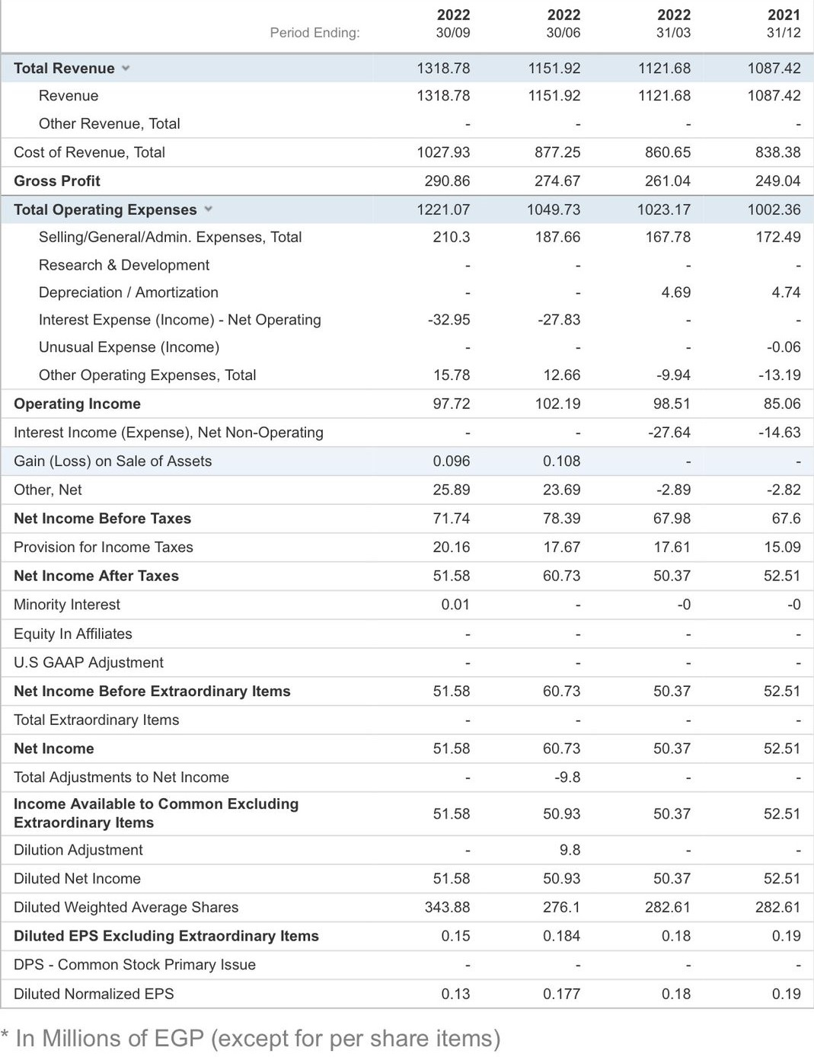

Balance sheet:
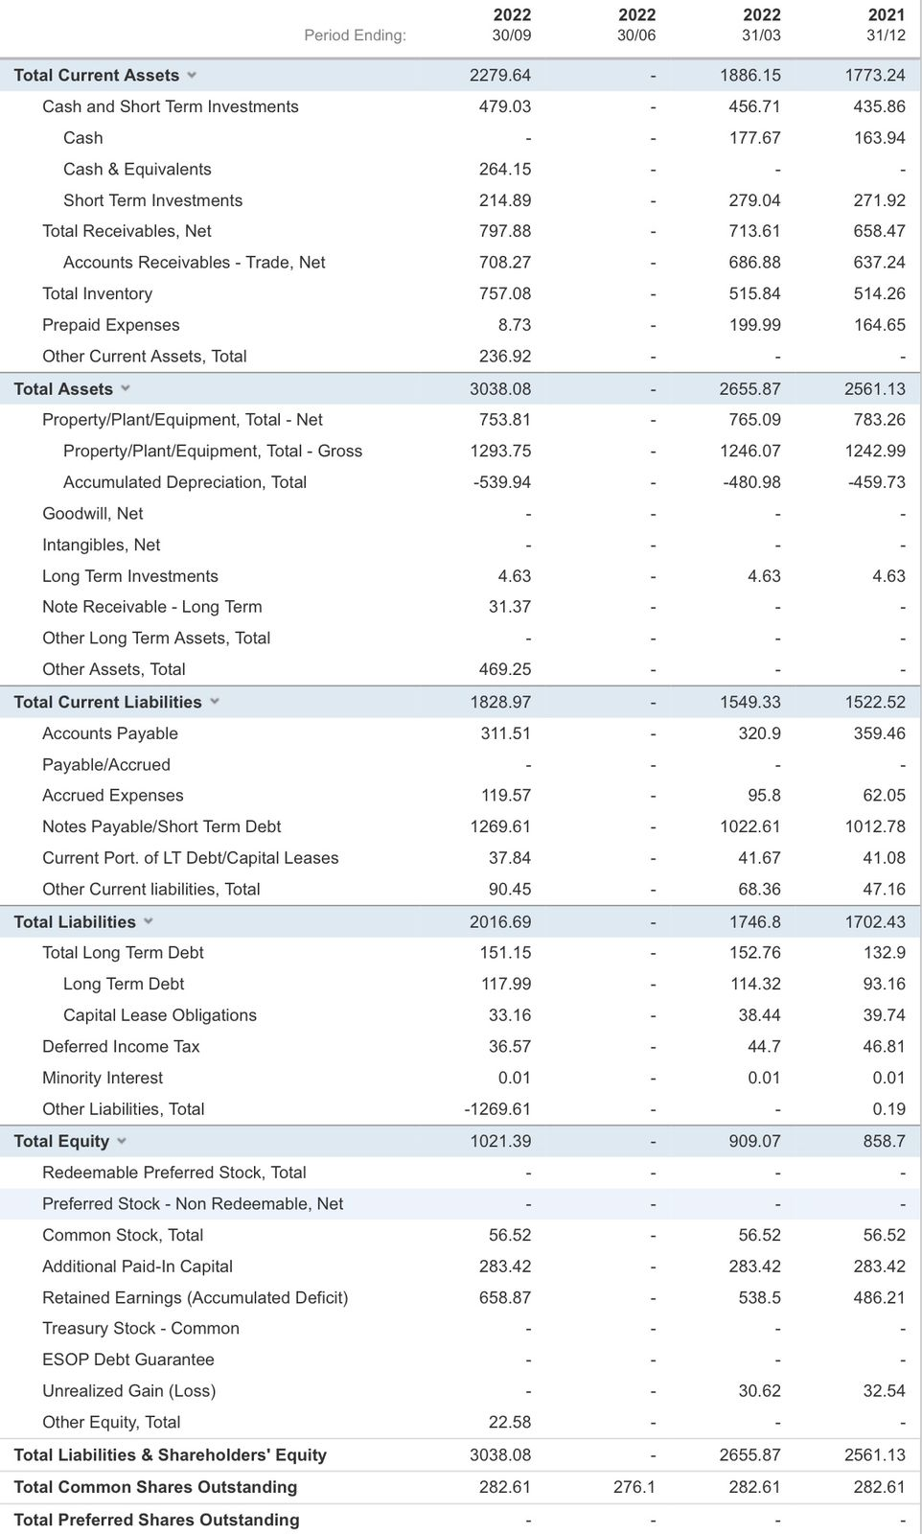

Cash flow statement:
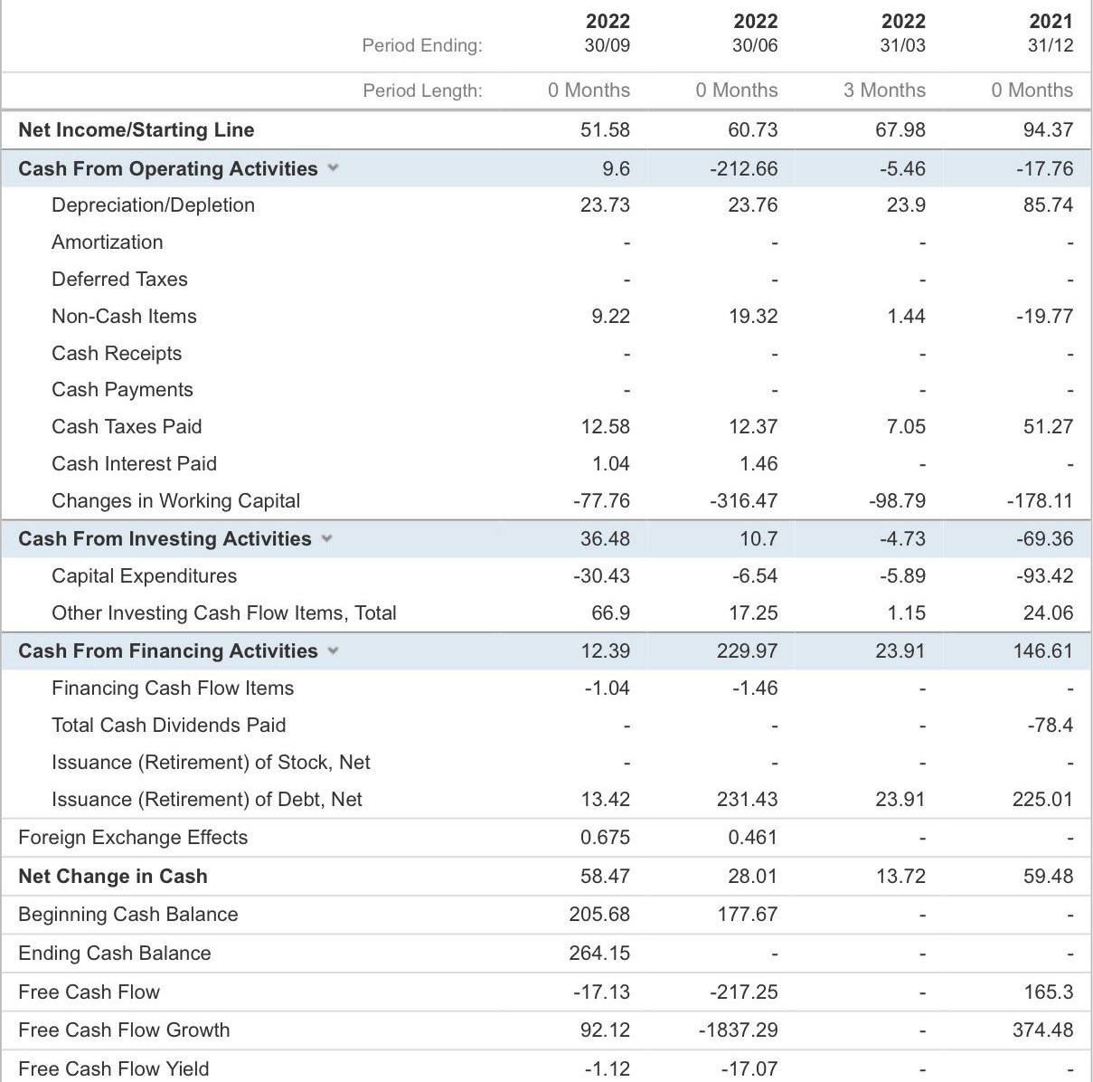

References:

Martins, Z. E., Pinho, O., & Ferreira, I. M. P. L. V. O. (2017). Food industry by-products used as functional ingredients of bakery products. Trends in Food Science & Technology, 67, 106-128.

Han, H., & Hyun, S. S. (2018). Eliciting customer green decisions related to water saving at hotels: Impact of customer characteristics. Journal of Sustainable Tourism, 26(8), 1437-1452.‏

Ormanidhi, O., & Stringa, O. (2008). Porter's model of generic competitive strategies. Business Economics, 43(3), 55-64.

Richards, J. I., & Curran, C. M. (2002). Oracles on “advertising”: Searching for a definition. Journal of advertising, 31(2), 63-77.

Dolgui, A., & Proth, J. M. (2010). Pricing strategies and models. Annual Reviews in Control, 34(1), 101-110.

Burns, L. D., Hall, R. W., Blumenfeld, D. E., & Daganzo, C. F. (1985). Distribution strategies that minimize transportation and inventory costs. Operations research, 33(3), 469-490.‏

Yüksekbilgili, Z. (2014). The use of guerilla marketing in SMEs. International Journal of Advanced Multidisciplinary Research and Review (IJAMRR), 2(2), 2-7.‏

https://www.damfi-eg.com/en

https://www.globaldata.com/store/report/egypt-baking-ingredients-market-analysis/

