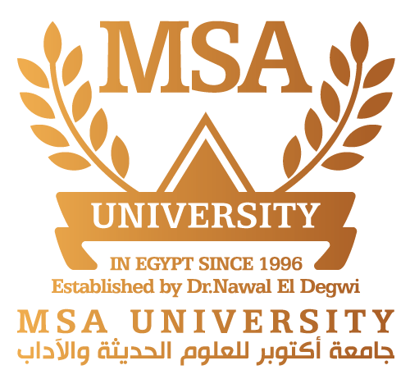

Faculty of Pharmacy
Pharmacognosy Department
Pharmacognosy (PHG112)
Cosmeceutical Use of Plants in Treatment of Hair Loss
Presented by: Xxxxxxxx Xxxxxxx Xxxxxxx
ID: 000000
Presented to: Dr. Xxxxxxxx Xxxxxxx

Individual Task
Name | ID | Task
1- | 000000 | -----------
2- | 000000 | -----------
3- | 000000 | -----------
4- | 000000 | -----------

Introduction
Cosmeceuticals definition: -----------------------------
What is hair?
Hairs can be defined as -"improved epithelial structure formed as a result of keratinization of germinative cells," hairs are the outgrowths from the follicles present on the skin. Hair is composed of keratin with chemical constituents such as Carbon (C), Nitrogen (N), Sulfur(S), & Oxygen (O)⁽¹⁾.
Hair loss
Hair loss known as alopecia, is one of the most distressing disorders as society places a great emphasis on physical appearance, hair loss mostly can be categorized into three
types: ⁽²⁾
• Noncicatricial (potentially reversible)
• Cicatricial
• Due to hair shaft abnormalities.
Among the common causes are fungal or bacterial folliculitis, discoid lupus erythematosus, and lichen planopilaris. Others include trauma, scarring bullous disorders (epidermolysis bullosa, bullous pemphigoid, porphyria cutanea), and neoplastic disease (skin tumors and cutaneous metastasis) ⁽³⁾.
Treatment is based on removing the cause, if the problem is traumatically induced. Leave-on conditioners that coat the hair fibers may increase hair strength and prevent breakage ⁽³⁾.
Herbs used in treating alopecia provide either one of the following ⁽¹⁾:
1. Nutritional support.
2. DHT blockers and 5-α-Reductase blockers.
3. Phytotherapy and improved scalp blood circulation.
Phytotherapy uses highly concentrated extracts which are derived from the flowers, leaves, bark and the roots of various plants like Arnica montana, Cedrus atlantica, Lavandula agustifolia, Oscimum sanctum, Pilocarpus jabarondi, Rosmarinus officinalis, Thyme vulgaris and also Lipidium sativum ⁽¹⁾ which was found in many market preparations and will conduct our research about.
Lepidium sativum L.
Origin:
It is the dried ripe seeds of Lepidium sativum L. family Brassicaceae (Cruciferae).
The Arabic name of Lepidium sativum is (حب الرشاد). While the common English name is Garden cress ⁽⁴⁾.
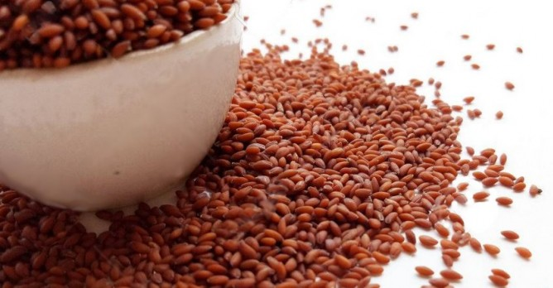

Figure (2): The seeds of Lepidium sativum.
Geographical disribution:
Lepidium sativum is natively found in the Mediterranean area. It is also cultivated in India and West Asia. Wild cress extends from Sudan to the Himalayas ⁽⁵⁾.
Morphology (description) of Lepidium sativum seed:
Seeds are small, oval in shape, pointed and triangular in shape at only one end, smooth in surface, approximately 3-4 mm long, 1-2 mm wide. It is reddish brown in color with a furrow present on both surfaces reaching up to two thirds in the end of the seed. A slight wing like prtrosion present on both the ends of the seed. After soaking the seed in water, the seed coat swells and a transparent, colorless, mucilage with mucilaginous taste layer appeared. The seed length is 298 ± 3.2µm and width 100 ±1.9 µm ⁽⁵⁾.

Cultivation and collection of Lepidium sativum seed:
Lepidium sativum (Garden cress) is considered as a spring to autumn crop, although it succeeds all-round the year but generally grows best in the cool season or at higher elevations around 2,400 metres. Seed collection of Lepidium sativum is time and effort consuming as the seeds drop easily ⁽⁶⁾.
Active constituents of Lepidium sativum seed:
The edible whole seed of Lepidium sativum is known to have health promoting properties. It contains mainly, mucilage, proteins, fats, fatty acid as linolenic acid and erucic acid, about 75% of the seed is dietary fibers, potassium and amino acid as glutamic acid, leucine and methionine ⁽⁷⁾.
Mechanism of action:
The application of Lepidium sativum liquid extract secures the supply of oxygen, blood and nutrients to the scalp resulting in immensely increase in growth factors thus lowers the rate of alopecia ⁽⁸⁾.
Uses of Lepidium sativum seed:
The seeds of L. sativum are known to have plenty of medicinal activity. It can act as a galactogogue, aperient, diuretic, alterative, tonic, demulcent, aphrodisiac, carminative and emmenagogue ⁽⁷⁾.
Mucilage content of the L. sativum seeds decreases the irritation of intestines that may be caused by abnormal acidity. The seeds can also be useful in hiccup, dysentery, diarrhea and skin diseases caused by impurities and toxins in blood and chronic enlargements of spleen ⁽⁸⁾.
Folk uses of Lepidium sativum seed:
Garden cress (Lepidium sativum) has been consumed as a highly nutritive food, since ancient times. Ages ago Western Asian, Mediterranean, and Indian cultures have used the seeds of garden cress to cause laxative effects, induce labor, or relieve pain ⁽⁹⁾.

Side effects of Lepidium sativum seed:
There is no confirmed information about the undesirable effects of garden cress, while consuming large amounts might cause intestinal irritation. It would be safer to avoid consuming a large amount of Lepidium sativum during pregnancy ⁽⁹⁾.
Lepidium sativum is believed to shows its toxic effects when injected in very high amounts that normal people will not take in the normal conditions ⁽¹¹⁾.
Pharmaceutical preparation of the seed:
The oil of the seed can be found in pharmaceutical preparations and also the dried seeds.
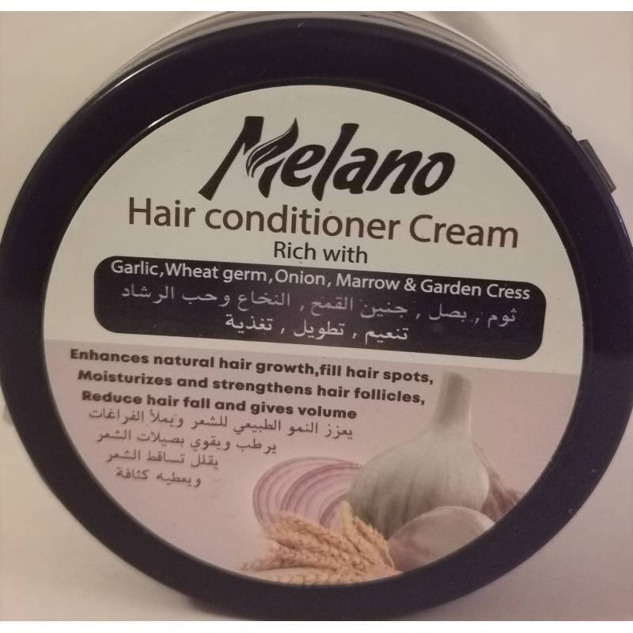
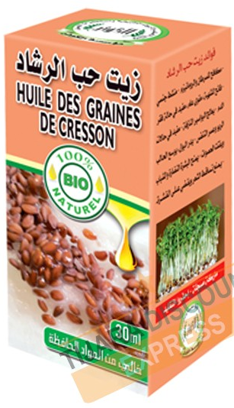
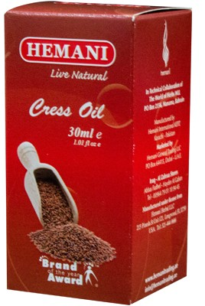

Figure (3): Different pharmaceutical preparations of the L. sativum seeds.

References:
- Mulinari-Brenner, F., & Bergfeld, W. F. (2001). Hair loss: an overview. Dermatology nursing, 13(4).
- Mulinari-Brenner, F., & Bergfeld, W. F. (2003). Hair loss: Diagnosis and management. Cleveland Clinic journal of medicine, 70(8), 705-712.
- Maluki, A. H., & DDV, F. (2009). Treatment of alopecia areata with topical garlic extract. Kufa medical journal, 12(1).
- Sharquie, K. E., & Al‐Obaidi, H. K. (2002). Onion juice (Allium cepa L.), a new topical treatment for alopecia areata. The Journal of dermatology, 29(6), 343-346.
- Kirtikar, K.R., 1918. Indian Medicinal Plants Vol-4. Bishen Singh Mahendra Pal Singh; Dehradun.
- Bigoniya, P., Singh, C.S. and Shukla, A., 2011. Pharmacognostical and physicochemical standardization of ethnopharmacologically important seeds of Lepidium sativum Linn. and Wrightia tinctoria R. Br.
- Albalawi, M. A., Hafez, A. M., Elhawary, S. S., Sedky, N. K., Hassan, O. F., Bakeer, R. M., ... & Mokhtar, F. A. (2023). The medicinal activity of lyophilized aqueous seed extract of Lepidium sativum L. in an androgenic alopecia model. Scientific Reports, 13(1), 7676.
- Gokavi, S.S., Malleshi, N.G. and Guo, M., 2004. Chemical composition of garden cress (Lepidium sativum) seeds and its fractions and use of bran as a functional ingredient. Plant Foods for Human Nutrition, 59(3), pp.105-111.
- Nadkarni KM, Nadkarni AK (1954) Lepidium sativum Linn. In: The Indian Materia Medica with Ayurvedic, Unani and Home remedies, 3rd edn. Bombay, India: Popular Prakashan, pp 736–737.
- Gokavi SS, Malleshi NG, and Guo M. Chemical composition of garden cress (Lepidium sativum) seeds and its fractions and use of bran as a functional ingredient. Plant Foods Hum Nutr 2004;59 (3):105-111.
- Sharma, S., & Agarwal, N. (2011). Nourishing and healing powers of garden cress (Lepidium sativum Linn.)-A review.
- Falana, H., Nofal, W., & Nakhleh, H. (2014). A Review Article Lepidium Sativum (Garden cress).

