**Criteria of Assignment PowerPoint Presentation**

The Presentation should start with a collective summarized **introduction** about the Disease/Condition, then the following information about the plant must be included:

1. **Origin of the chosen plant (including part used, genus, species, family, English and Arabic name).**
2. **Picture of the organ used from the plant (with the highest content of the main active constituent).**
3. **Active constituents (provide the structure of the main active constituents).**
4. **Uses of the plant (with pictures as possible).**
5. **The mechanism of action of the main active constituent (summarized).**
6. **Picture of the pharmaceutical preparation from the Egyptian or the international market that include the whole plant, an extract, or a compound from this plant.**

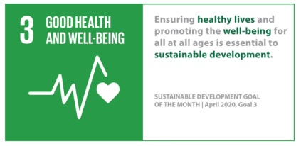******Make sure that the fonts are clear, student names, ID, Course name, Code, and Course Coordinator are written under the title,- MSA and Greenwich logo is included- and all the used references are included. In addition to the SDG logo:



* References are written in numerical style.
* Use white background.
* The font is Times New Roman_**BOLD**.
* Font Size:**Title 60**, **Heading 40** and **Text 24** (or whatever suitable and readable).
* All the information should be clear, summarized and to the point with the addition of illustration as much as possible.
* The deadline for ppt. **submission** is **Wednesday 30/4/2025 11:55 pm.**
* Deadline of the **discussion for each students group in their lab at Week 12 Mon 18/5/2025 to Wed 21/5/2025.**
* **Best ppt design will be selected for participating in the Pharmacognosy conference day in Tuesday 20/5/2025 from 12:00 to 2:00 pm.**